Fundamentals of Data Science

Final Assessment Project Report
Student Profile Management System
GitHub URL: https://github.com/siddSah2913/FODSFinalAssessment

Group Members
Yugant Adhikari
Sumnima Dhungana
Shreya Bista
Siddhant Sah

Submission Date: 19 April 2026
1. Introduction
This report documents the Student Profile Management System we built as part of the FODS final assessment. The idea behind the project is fairly straightforward - schools and colleges deal with a lot of student data every day and managing all of it manually is messy and error-prone. Our system tries to fix that by giving both admins and students a clean, menu-based interface to handle personal records, exam grades, and extracurricular activities.
We built everything in Python using object-oriented programming, plain file handling, numpy and matplotlib for data visualization. The program reads from and writes to four text files that act as our data store. The system supports two types of users - admin and student - each with their own set of features and permissions.
The project was split across four group members, with each person responsible for a specific part of the codebase. This report walks through the system design, the code structure, how we tested things, and what we found during development.

2. System Overview
2.1 Project Objective
The objective was to build a Student Profile Management System that handles student personal information, examination data, and extracurricular activities using four text files as storage. The system had to implement OOP concepts, file handling, exception handling, and some form of data visualization.

2.2 Data Files
The system uses four plain text files. Each line in the file is comma-separated:
File | Purpose | Format
users.txt | Stores all registered users and their roles | user_id, name, role
passwords.txt | Stores login credentials | user_id, password
grades.txt | Stores marks for 5 subjects per student | user_id, Math, CS, English, Science, Nepali
eca.txt | Stores extracurricular activity records | user_id, activity1, activity2, ...

2.3 User Roles
There are two roles in the system. Admin accounts can manage all student data - adding, editing, or deleting records - and access the analytics dashboard. Student accounts have read access to their own profile, grades, and ECA records, plus the ability to update their own name and visualise their grades as a bar chart.

2.4 Tech Stack
- Language: Python 3
- Visualisation: matplotlib
- Numerical operations: numpy (used in trend line calculations)
- Storage: Plain .txt files (comma-separated)
- No external database - everything is file-based

3. System Design
3.1 Class Structure
We used Object-Oriented Programming throughout the project. There is a base class called User, and two subclasses - Student and Admin - that inherit from it. This structure kept things clean and made it easy to separate admin-only features from student features.
Class | Inherits From | Key Responsibilities
User | - | Base class. Holds user_id, name, role. Has show_profile() and update_profile() methods.
Student | User | View grades, view ECA, plot grades, student menu loop.
Admin | User | Add/view/delete students, update grades/ECA, analytics dashboard, admin menu loop.

3.2 Key Functions
Outside the classes, there are a few helper functions that most of the system relies on:
- setup_files() - Creates the four data files with sample data if they do not exist when the program starts.
- read_file(filename) - Opens a file and returns each non-empty line as a list item. Wrapped in try/except to handle missing files gracefully.
- write_file(filename, lines) - Writes a list of strings back to a file, one per line. Also wrapped in try/except.
- divider() - A simple utility that prints a separator line to keep the console output readable.
- login() - Validates username and password against passwords.txt. Returns a Student or Admin object depending on the role found in users.txt.

3.3 Login Flow
When the program starts, it immediately calls setup_files() and then enters a login loop. The user gets up to three attempts before the program exits for security reasons. Once logged in, the system checks the role and routes the user either to admin_menu() or student_menu(). After logging out, the program asks if another user wants to log in.

3.4 Flowchart
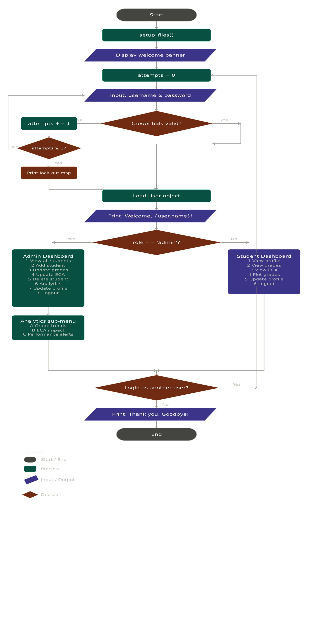
4. Features and Implementation
4.1 Login System
The login system reads passwords.txt line by line and checks if both the username and password match an entry. If they do, it then looks up the corresponding user in users.txt to determine the role. If authentication fails, an error message is shown and the user is prompted again. After three failed attempts, the program exits. This basic approach is intentional - the brief specifies simple storage for learning purposes.

4.2 Admin Features
4.2.1 Add New Student
The add_student() method asks the admin for a student ID, name, password, marks for five subjects, and ECA activities. It first checks whether the ID already exists in users.txt to prevent duplicates. The marks input includes input validation - it keeps asking until a number between 0 and 100 is entered. Once all details are collected, the data is appended to each of the four files.
4.2.2 View All Students
The view_all_students() method reads users.txt, filters for entries where the role is 'student', and prints them in a formatted table showing ID, name, and role. This is also reused inside update_grades(), update_eca(), and delete_student() so the admin can see the available IDs before entering one.
4.2.3 Update Grades
The update_grades() method shows all students first, asks for an ID, then goes through grades.txt to find that student's record. It shows the current mark for each subject and lets the admin enter new values. Input validation ensures only valid numbers between 0 and 100 are accepted. Once done, the updated list is written back to the file.
4.2.4 Update ECA
Similar to updating grades, update_eca() finds the student's current ECA record, displays it, and lets the admin enter a new comma-separated list of activities. If the student had no ECA record at all, a new one is added. If the admin leaves the input blank, it stores 'None'.

4.2.5 Delete Student
The delete_student() method first shows the list of students, then asks for the ID to delete. It checks that the ID exists and belongs to a student (not an admin). Before deleting, it asks for confirmation with a yes/no prompt. If confirmed, the student's entries are removed from all four files by filtering out any line that starts with that ID.

4.3 Student Features
4.3.1 View Profile
Calls the inherited show_profile() method from the User base class, which prints the student's name, ID, and role.
4.3.2 View Grades
The view_grades() method reads grades.txt, finds the matching student ID, and prints each subject alongside its mark and a simple ASCII bar chart (made of '#' characters). It also calculates and displays the average, and assigns an overall grade letter (A, B, C, or F) based on the average.
4.3.3 View ECA Activities
Reads eca.txt and displays a numbered list of the student's extracurricular activities. If no record is found, it shows an appropriate message.
4.3.4 Plot Grades (Chart)
The plot_grades() method uses matplotlib to draw a bar chart of the student's subject marks. Each bar is a different colour, marks are labelled on top of each bar, and a dashed red horizontal line shows the average. This was one of the creativity bonus features the brief mentioned.
4.3.5 Update Profile
Inherits update_profile() from the User class. Lets the student change their own name, which is reflected in users.txt immediately.

4.4 Performance Analytics Dashboard (Bonus Task 2)
The analytics dashboard is only accessible by admins. It has three sub-features accessible through an inner menu (A / B / C / D to go back):
4.4.1 Grade Trends
Reads all student grade records and plots a line chart showing each student's marks across the five subjects. A dashed grey line shows the class average. Below the chart, it prints a summary table with each student's marks, average, and letter grade. This gives the admin a quick overview of where the class stands subject by subject.
4.4.2 ECA Impact
This feature tries to find out whether students who are more involved in ECA activities tend to get better or worse grades. It counts each student's number of ECA activities and compares it with their grade average. A Pearson-style correlation coefficient is calculated manually (without pandas or scipy) using the standard formula. The result is displayed along with a scatter plot and a grouped bar chart.
4.4.3 Performance Alerts
The admin enters a threshold percentage. The system then finds all students whose average falls below that threshold and prints a breakdown for each one - showing their weakest subjects, their strongest subject, their ECA load, and specific suggestions for improvement (like extra tutoring or adjusting ECA involvement). A horizontal bar chart highlights which students are below the threshold in red and which are above in green.

5. Object-Oriented Programming Concepts Used
The brief specifically asked for OOP concepts, so here is how we used them:
Concept | How We Used It
Classes | User, Student, and Admin are all classes with their own attributes and methods.
Inheritance | Student and Admin both inherit from User. They call super().__init__() to set up the base attributes.
Encapsulation | Each class keeps its own data (user_id, name, role) and exposes only what is needed through methods.
Method Overriding | Both Student and Admin have their own menu methods (student_menu and admin_menu) that replace the base behaviour.
Polymorphism | The main() function calls show_profile() on whichever user object is returned by login() - it works the same way regardless of whether it is a Student or Admin.

6. Exception Handling
We wrapped most of the critical sections in try/except blocks. Here is a summary of where and how:

- read_file(): Catches FileNotFoundError if a file is missing and creates a blank one, so the program does not crash on first run. A general Exception catch handles anything unexpected.
- write_file(): Catches any Exception during file writes and prints a message so the user knows something went wrong.
- view_grades() and plot_grades(): Catches ValueError specifically, which would be raised if a mark stored in the file is not a valid integer (e.g. corrupted data). A general Exception catch handles the rest.
- add_student() / update_grades(): Input validation loops catch ValueError from int() conversions when the user types something that is not a number.
- analytics_eca_impact(): Catches ZeroDivisionError in case there is only one student (which would make the correlation denominator zero).
- login(): The entire function is wrapped in try/except to make sure a crash during authentication does not break the main loop.
- analytics_performance_alerts(): The threshold input is validated in a loop that catches ValueError, so typing letters instead of a number does not break anything.

7. Testing
7.1 Test Cases
We tested the system manually by running the program and going through each feature. Below is a table of the main test cases we checked:

Test Case | Input | Expected Outcome | Result
Login with valid admin credentials | admin01 / admin123 | Admin dashboard loads | Pass
Login with valid student credentials | s001 / pass1234 | Student dashboard loads | Pass
Login with wrong password | admin01 / wrongpass | Error message, re-prompt | Pass
Three failed login attempts | Wrong creds x3 | Program exits with message | Pass
Add student with duplicate ID | s001 (already exists) | Error message, re-prompt for ID | Pass
Add student with invalid mark | Math: abc | Error message, re-prompt for mark | Pass
Delete student with confirmation | s002, yes | Student removed from all files | Pass
Delete student - cancel | s002, no | Cancelled, no changes | Pass
View grades for student s001 | Login as s001 | Grades with bar chart and average displayed | Pass
Plot grades for student s001 | Option 4 in student menu | Matplotlib bar chart opens | Pass
Grade Trends chart (admin) | Option A in analytics | Line chart with all students plotted | Pass
ECA Impact with one student | Single student in grades.txt | Shows weak/no correlation message | Pass
Performance Alerts below threshold | Threshold: 80 | Students below 80 listed with suggestions | Pass
Update profile (student) | New name entered | Name updated in users.txt | Pass
Update ECA for student | New activities entered | ECA record updated in eca.txt | Pass

7.2 Test Output Screenshots
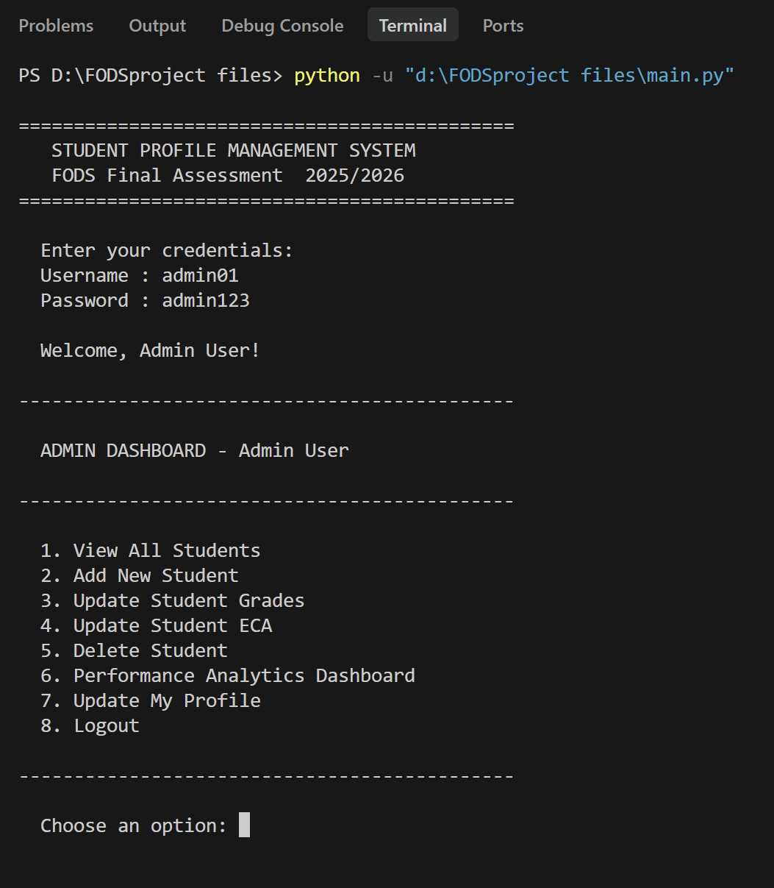
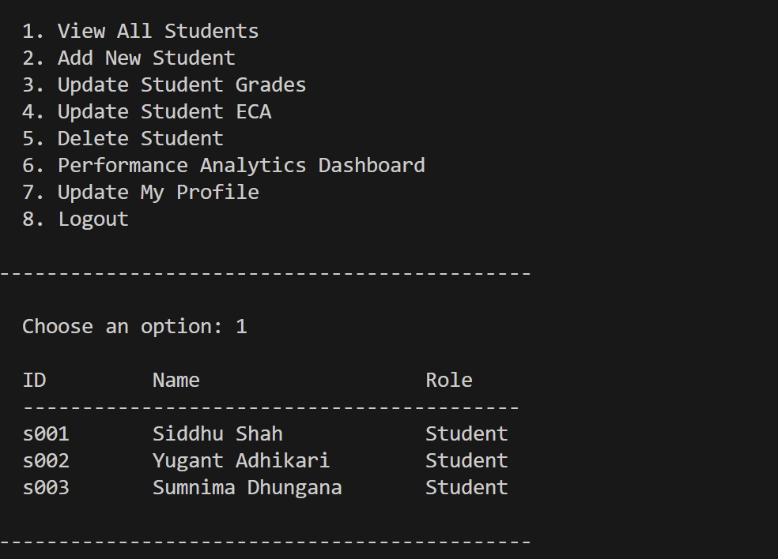
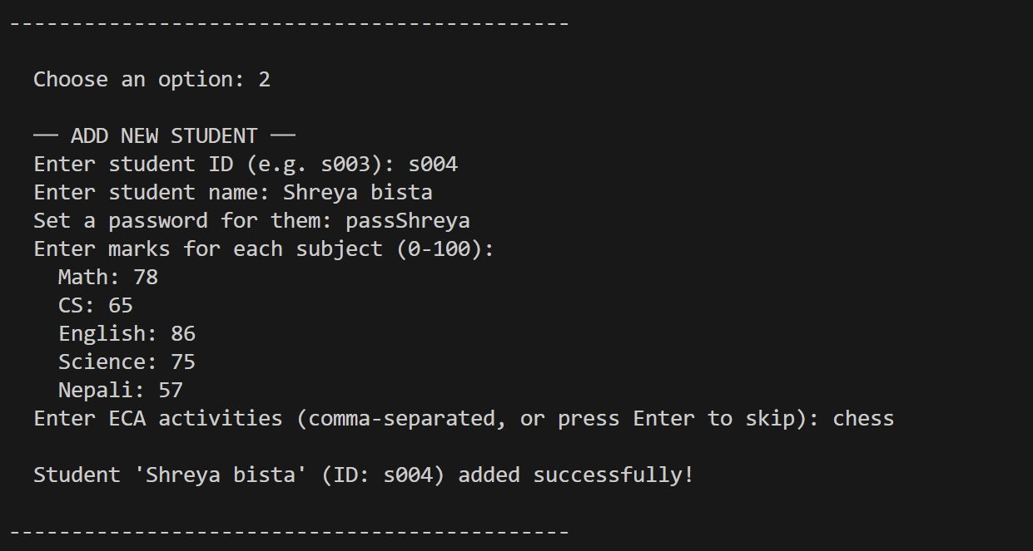
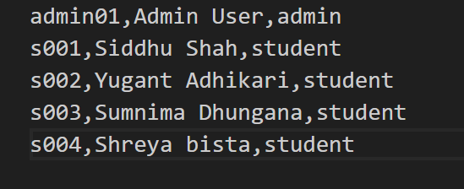
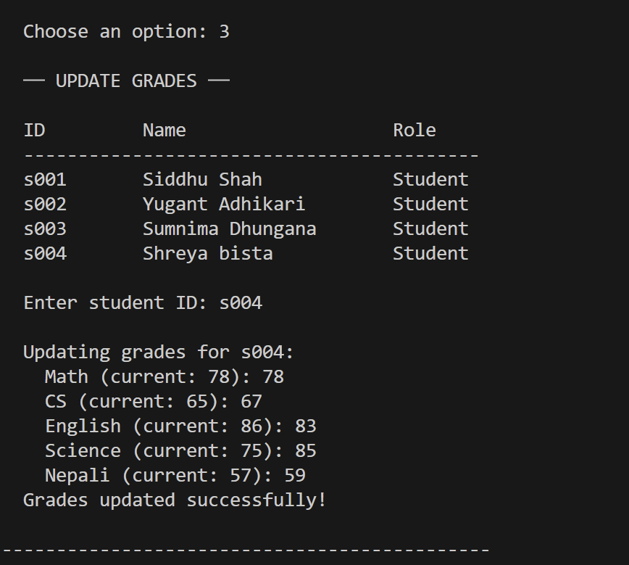
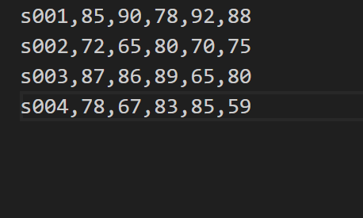
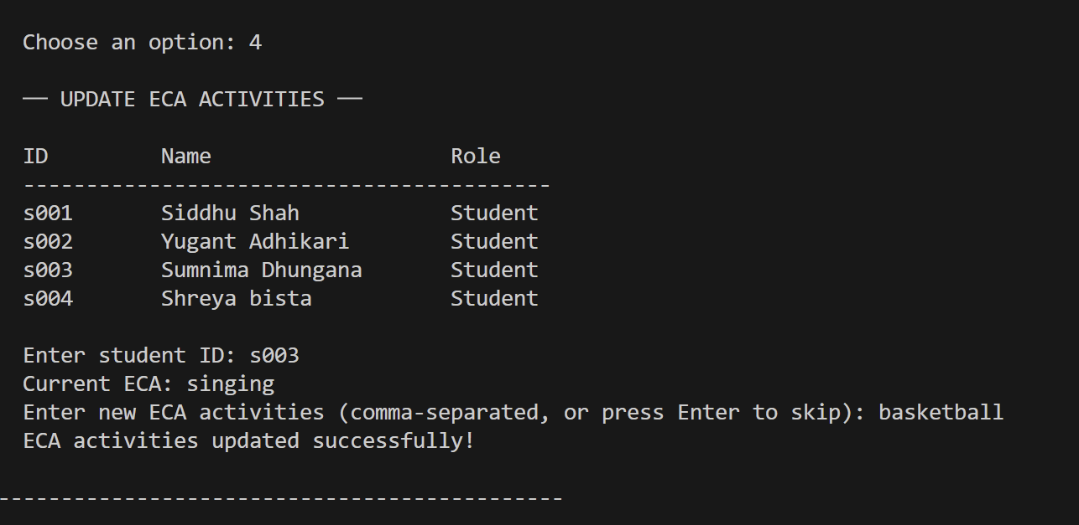
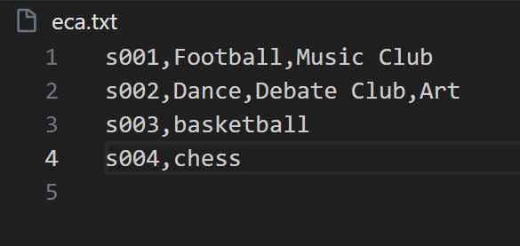
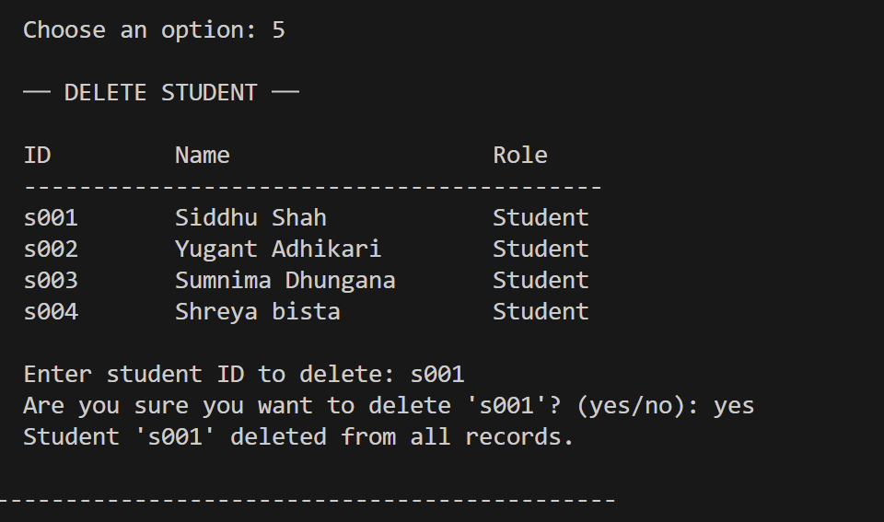
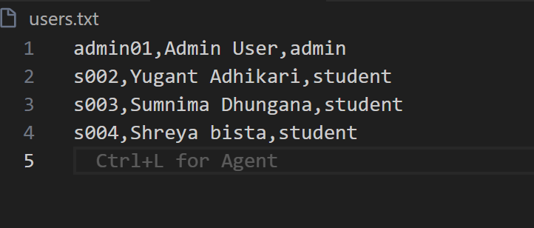
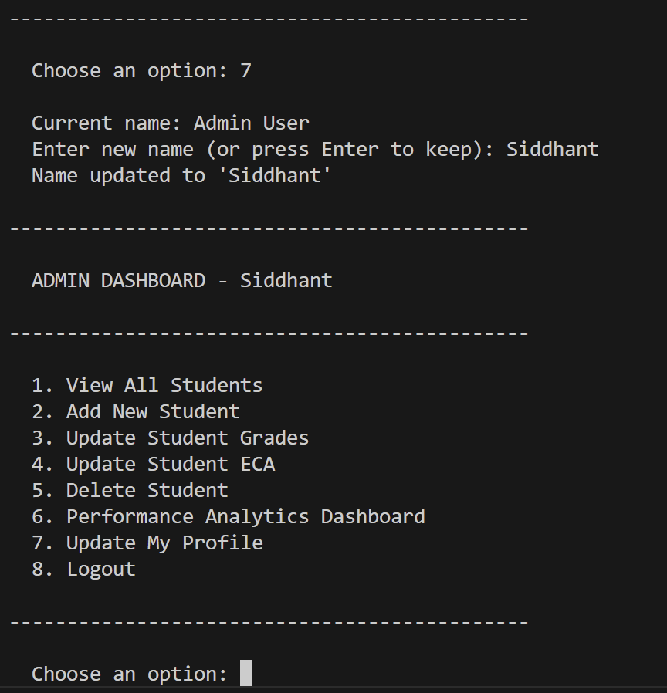
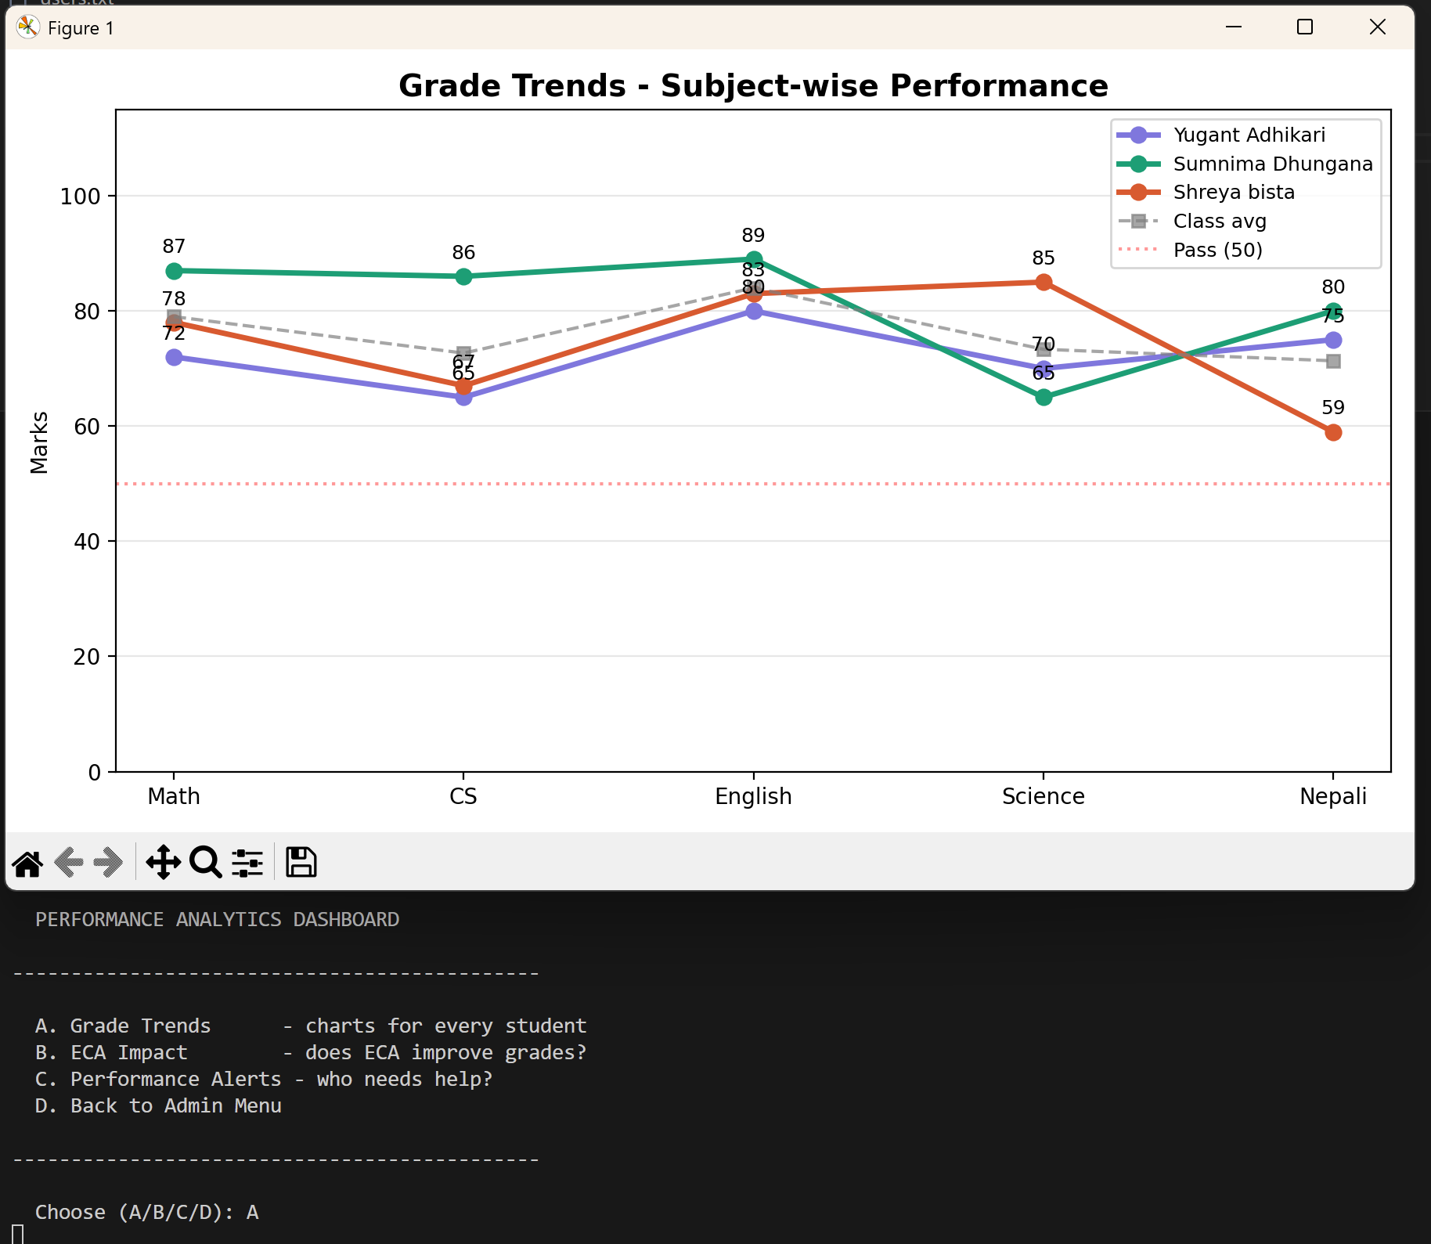
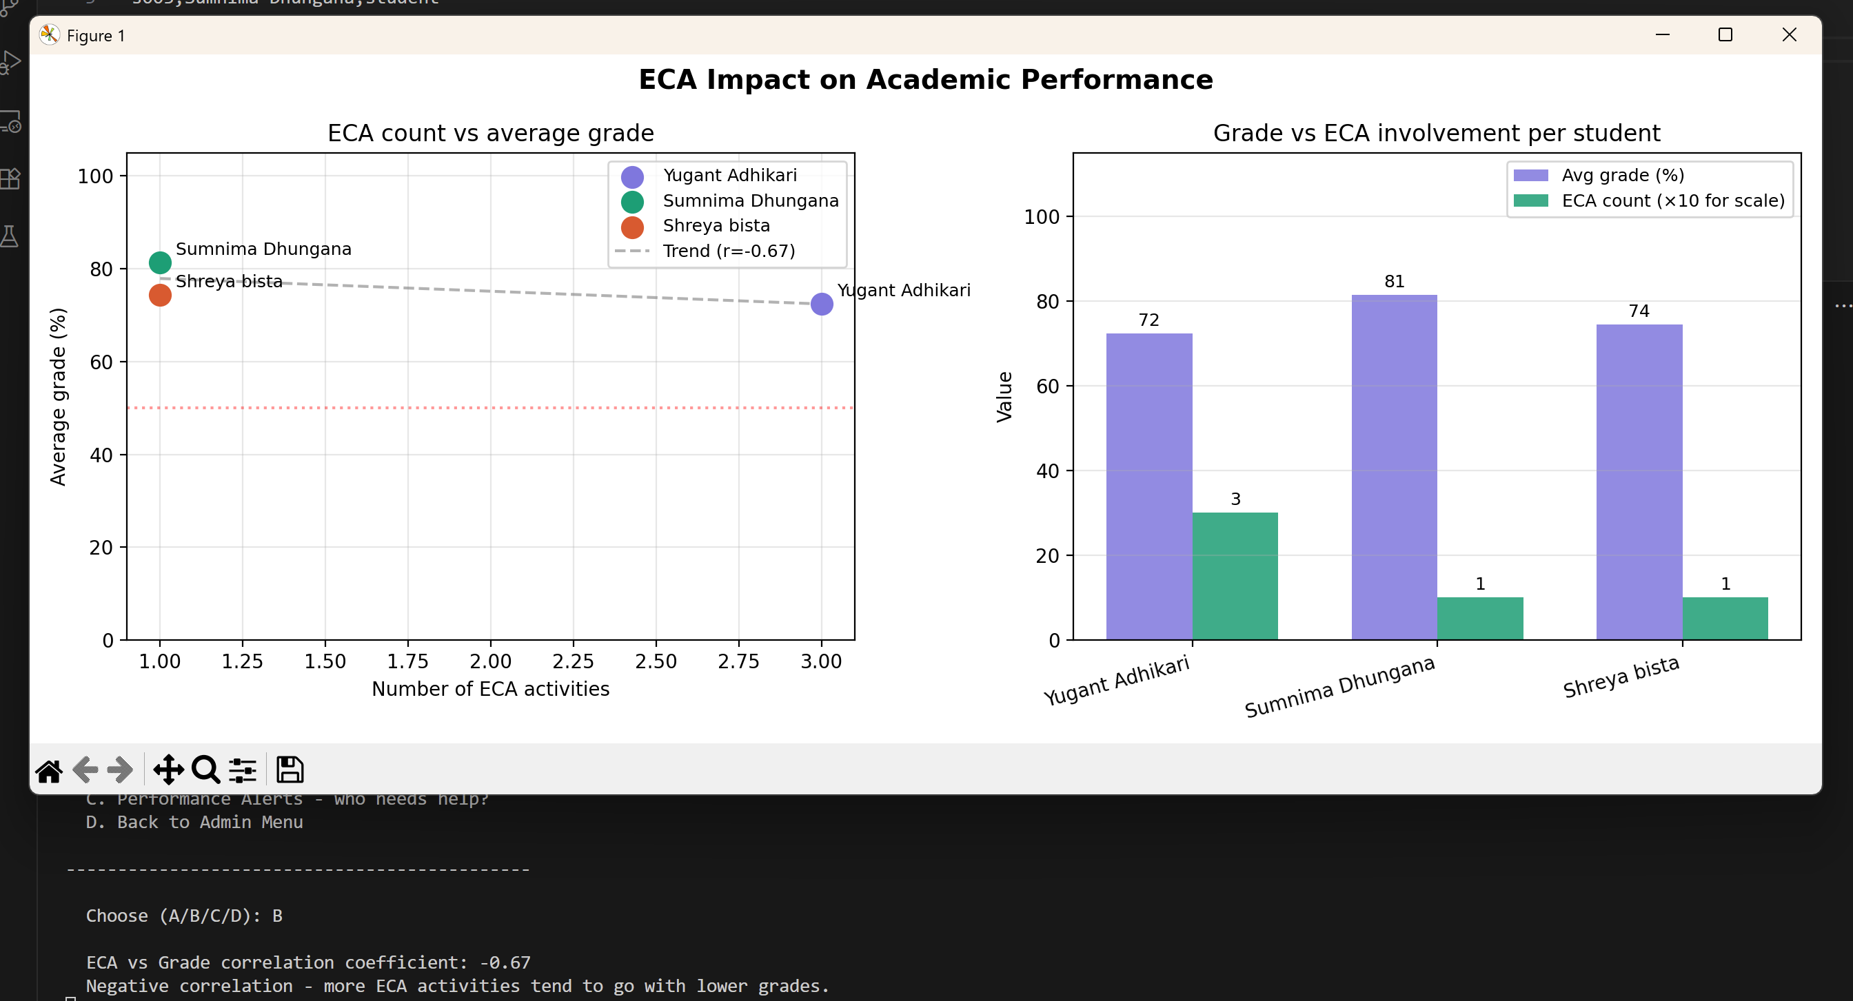
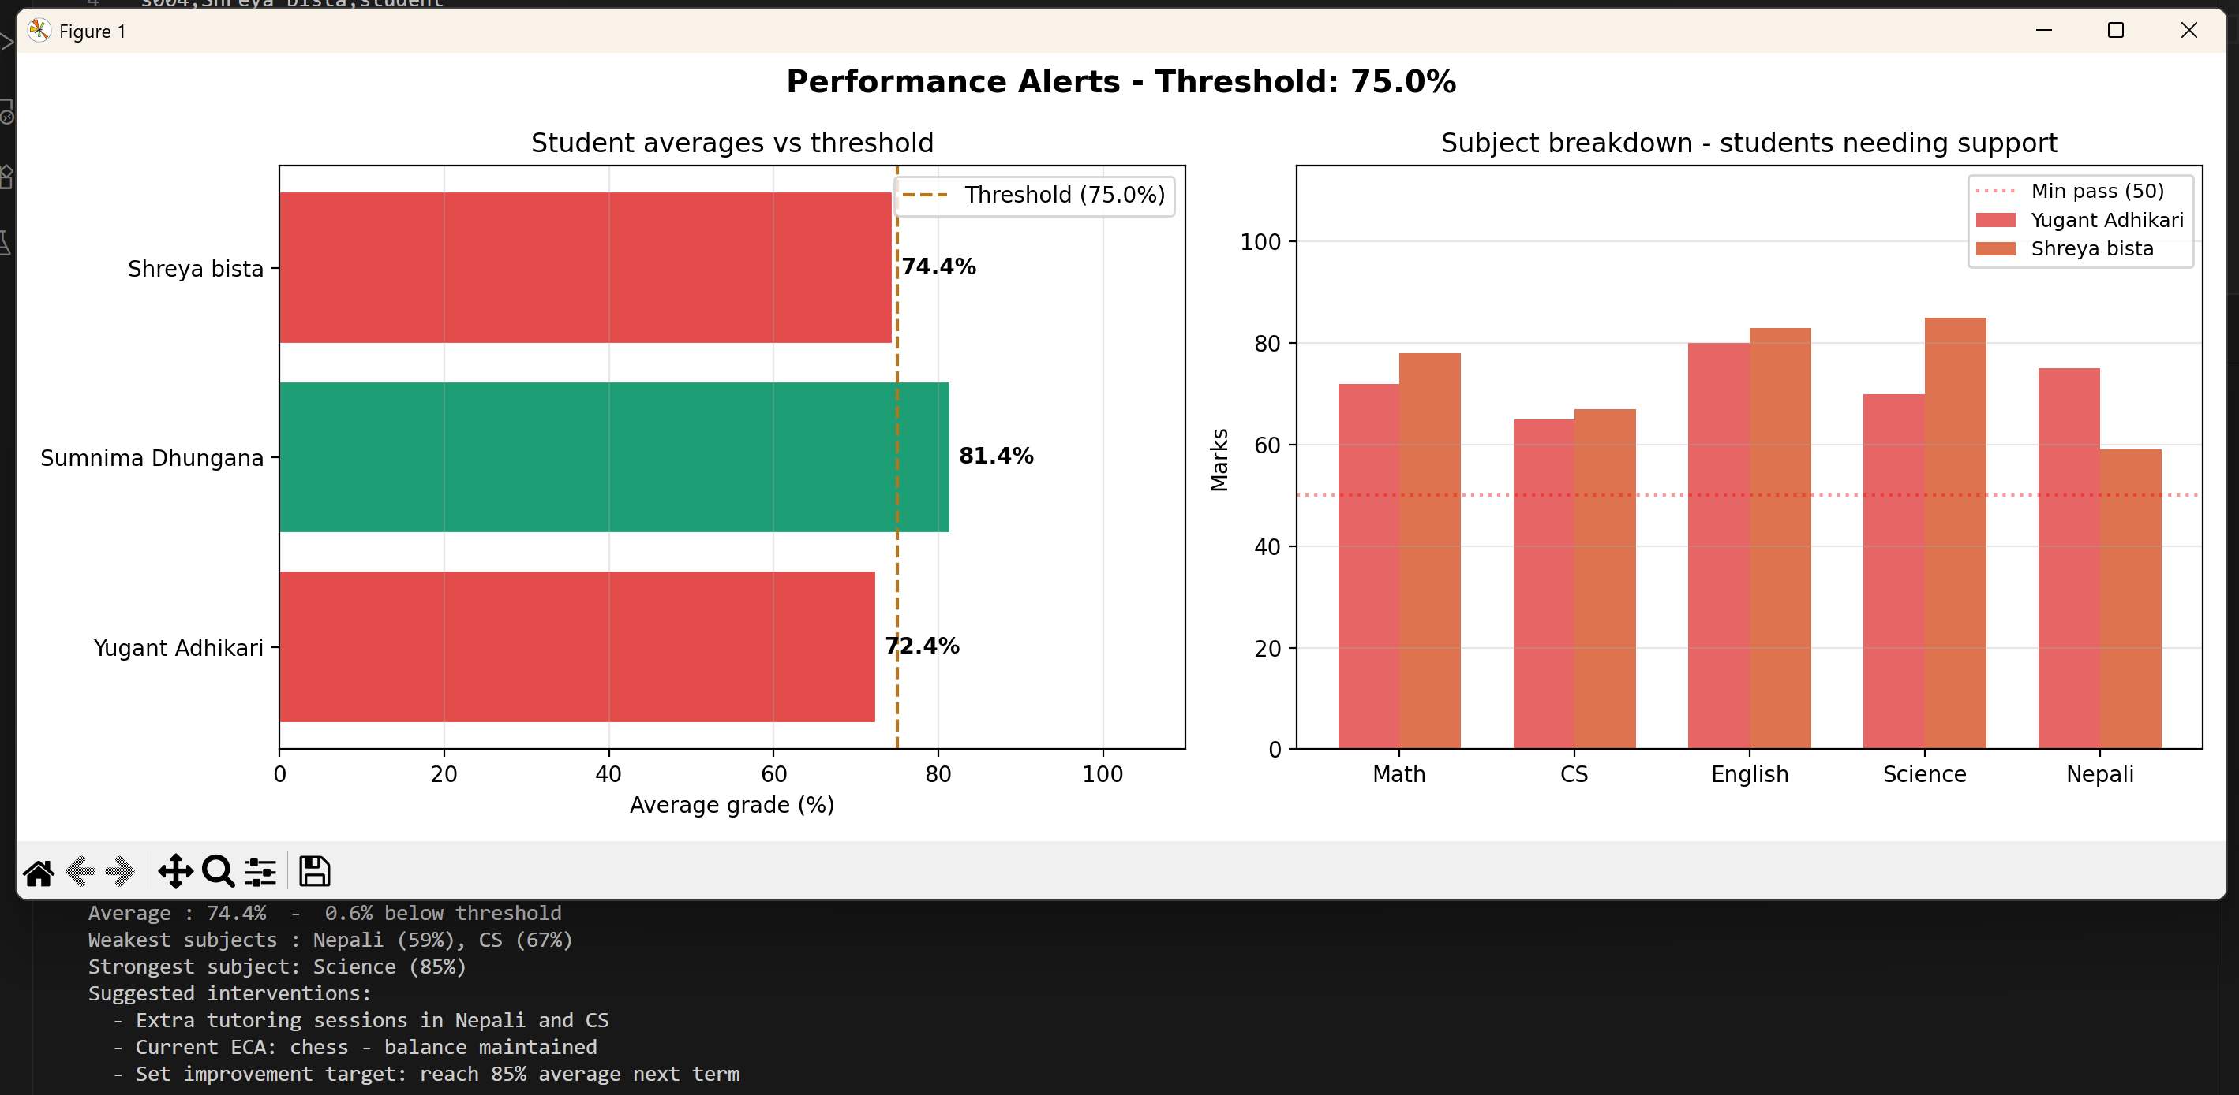
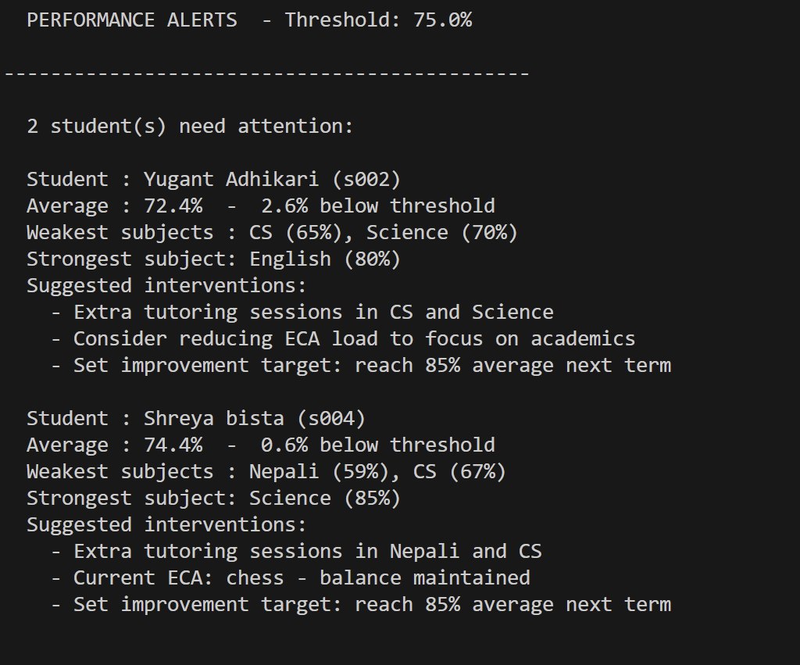
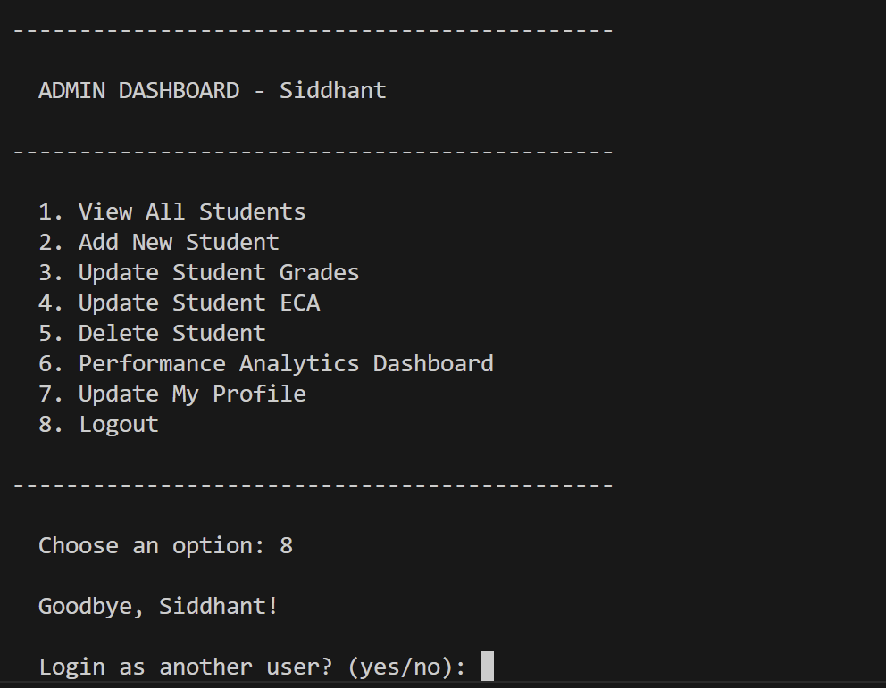
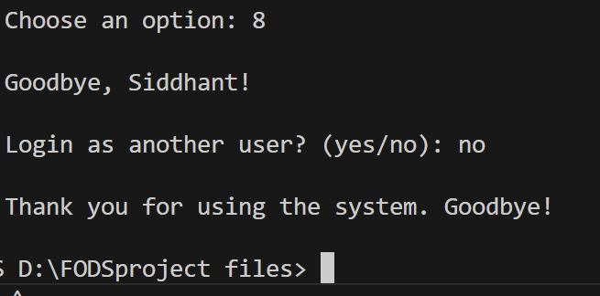
8. Work Contribution
The work was divided roughly equally across all four members. Each person had a primary area of responsibility, but we all reviewed each other's code before finalising.
Member | Primary Contribution
Siddhant Sah | Login system, file setup (setup_files, read_file, write_file), User base class, overall program structure and main() loop, integration testing.
Yugant Adhikari | Admin class - add_student(), view_all_students(), delete_student(), update_grades(), update_eca(). Admin menu loop.
Sumnima Dhungana | Student class - view_grades(), view_eca(), plot_grades(), student_menu(). ASCII bar chart formatting in console output.
Shreya Bista | Performance Analytics Dashboard - analytics_grade_trends(), analytics_eca_impact(), analytics_performance_alerts(). All matplotlib charts in the analytics section.

Beyond these primary areas, all four of us contributed to testing, debugging, and writing this report. The exception handling was also reviewed and improved by the whole group in the final stages.

10. Conclusion
The Student Profile Management System meets all the basic requirements set out in the brief. It has a working login system with role-based access, full CRUD operations for admin, read and update features for students, file-based data storage using four text files, OOP with inheritance, exception handling throughout, and data visualisation using matplotlib.
We also completed both bonus features - the grade bar chart for students (from Task 1 creativity points) and the full Performance Analytics Dashboard with grade trends, ECA impact analysis, and performance alerts (Task 2).
If we were to take this further, the most obvious next steps would be adding password hashing for security, moving to a proper database like SQLite, and building a simple GUI instead of a console interface. But for the scope of this module, we are happy with what we put together.

